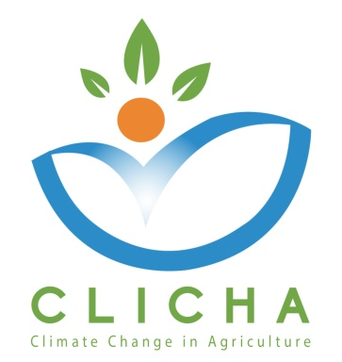

2ndTransnational Meeting Evaluation

WP 3–Quality Assurance

AUA
WP Leader

October, 2018

CLICHA
CLIMATE CHANGE IN AGRICULTURE
Project Nr. 586273-EPP-1-2017-1-EL-EPPKA2-CBHE-JP

Meeting Evaluation Form
Dear colleague,
Thank you for your participation in this meeting. You are kindly requested to take part in this short survey. Your feedback is very valuable in view of the further project progress and performance. All data will be treated confidentially.
Please answer each question with a grade between 1-5, where 1 is Poor and 5 is Excellent.
If you give 1 or 2, please explain why, using the comment space below. It would be helpful to have your comments or suggestions.

 | 1 | 2 | 3 | 4 | 5
- The meeting was well planned and organized. |  |  |  | x
- The agenda of the meeting was clear, balanced, focusing on all key topics. |  |  |  |  | x
- The topics were presented and discussed in a clear and understandable manner. |  |  |  | x
- The timetable was respected. |  |  |  | x
- All participants had to opportunity to express their observations/comments/questions about the topics of the meeting. |  |  |  | x
- The meeting provided added value with respect to the progress of the project and the scheduling of the next steps. |  |  |  |  | x
- Access to the venue of the meeting was easy. (*) |  |  |  |  | x
- The conference room and its facilities facilitated the work during the meeting. (*) |  |  |  | x
- Catering and meals were satisfactory. (*) |  |  |  |  | x
Comments / Suggestions:

Successful meeting

(*) In case of long-distance meetings (teleconferences/videoconferences/skype meetings), questions (7), (8) and (9) should not be answered.

Name & Organization: (optional): Dr. Rafik ALOULOU, P6_US_ISA-CM

Thank you for your cooperation!

