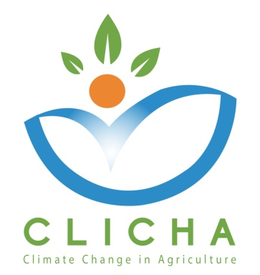

Communication and Exploitation Plan

WP 3 – Quality Assurance

AUA and CRETHIDEV
WP Leaders

November, 2018

CLICHA
CLIMATE CHANGE IN AGRICULTURE
Project Nr. 586273-EPP-1-2017-1-EL-EPPKA2-CBHE-JP
Document Data

Deliverable: Communication and Exploitation Plan
Work Package No & Title: WP3 - Quality Assurance
Work Package Leader: P1- AUA (Greece)
Work Package Co-Leaders: P2 - CRETHIDEV (Greece)
Partners involved: P3 National Centre for Scientific Research “Demokritos” (DEMOKRITOS) - (Greece), P4 University of Jendouba (UJ) - (Tunisia), P5 - The University of Carthage (UCAR) - (Tunisia), P6 - University of Sousse (US) - (Tunisia), P7 - The National Institute of Field Crops (INGC) - (Tunisia), P8 - Centre of Adaptation to Climate Changes (CACC) - (Tunisia), P9 - Latvia University of Life Sciences and Technologies (LLU) - (Latvia), P10 - Università degli Studi di Torino (UNITO) - (Italy)
Distribution level: Partnership (Confidential)
Reviewed by: Consortium
Document Version: 1
Status: Draft

Document History

Version | Date | Author/Organization | Changes
0.1 | 30/11/2018 | CRETHIDEV - AUA | First Draft

Disclaimer

This project has been funded with the support of the Erasmus+ Programme of the European Union.

The information and views set out in this publication are those of the author(s) and do not necessarily reflect the official opinion of the European Commission and/or the Education, Audiovisual and Culture Executive Agency. Neither the European Commission nor the Education, Audiovisual and Culture Executive Agency, not any person acting on the Commission’s behalf and/or the Education, Audio-visual and Culture Executive Agency’s behalf, may be held responsible for any use which may be made of the information contained therein.

All rights are reserved. Reproduction is authorized, except for commercial purposes, provided the source is acknowledged.

Copyright © CLICHA Consortium, 2017-2020

Communication and Exploitation Plan

The purpose of the Communication and Exploitation Plan is to describe and set the standards for all dissemination, communication and exploitation activities which will be performed by the CLICHA consortium to ensure consistent and effective project visibility.

Participants
According to the Quality Plan, the Communication and Exploitation Plan is to be evaluated by the University of Jendouba and National Centre for Scientific Research “Demokritos”
PARTNERS | Number of participants
P3 - National Centre for Scientific Research “Demokritos” (DEMOKRITOS) | 1
P4 - University of Jendouba (UJ- ESIER) | 1
 | Total: 2

Results presentation
Below are shown the evaluation graphs.

Conclusions and Recommendations
The plan was accepted without changes.

