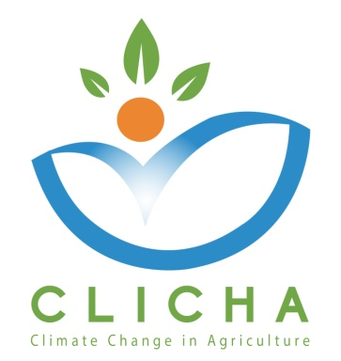

Cognitive Content Deliverable Evaluation

WP 3 – Quality Assurance

AUA and CRETHIDEV
WP Leaders

November, 2018

CLICHA
CLIMATE CHANGE IN AGRICULTURE
Project Nr. 586273-EPP-1-2017-1-EL-EPPKA2-CBHE-JP
Document Data

Deliverable: Cognitive Content
Work Package No & Title: WP3 - Quality Assurance
Work Package Leader: P1- AUA (Greece)
Work Package Co-Leaders: P2 - CRETHIDEV (Greece)
Partners involved: P3 National Centre for Scientific Research “Demokritos” (DEMOKRITOS) - (Greece), P4 University of Jendouba (UJ) - (Tunisia), P5 - The University of Carthage (UCAR) - (Tunisia), P6 - University of Sousse (US) - (Tunisia), P7 - The National Institute of Field Crops (INGC) - (Tunisia), P8 - Centre of Adaptation to Climate Changes (CACC) - (Tunisia), P9 - Latvia University of Life Sciences and Technologies (LLU) - (Latvia), P10 - Università degli Studi di Torino (UNITO) - (Italy)
Distribution level: Partnership (Confidential)
Reviewed by: Consortium
Document Version: 1
Status: Draft

Document History

Version | Date | Author/Organization | Changes
0.1 | 30/11/2018 | CRETHIDEV - AUA | First Draft

Disclaimer

This project has been funded with the support of the Erasmus+ Programme of the European Union.

The information and views set out in this publication are those of the author(s) and do not necessarily reflect the official opinion of the European Commission and/or the Education, Audiovisual and Culture Executive Agency. Neither the European Commission nor the Education, Audiovisual and Culture Executive Agency, not any person acting on the Commission’s behalf and/or the Education, Audio-visual and Culture Executive Agency’s behalf, may be held responsible for any use which may be made of the information contained therein.

All rights are reserved. Reproduction is authorized, except for commercial purposes, provided the source is acknowledged.

Copyright © CLICHA Consortium, 2017-2020

Cognitive Content
The purpose of this deliverable is the collection and compilation from all project partners, relevant educational material, which will be used in order to create the final educational products (courses / series of lectures). For this reason, a codification matrix was developed to facilitate collection of material.

Participants

Four members, each from one HEIs of the consortium, participated in this evaluation.
PARTNERS | Number of participants
P1 – Agricultural University of Athens (AUA) | 1
P5 - The University of Carthage (UCAR) | 1
P9 - Latvia University of Life Sciences and Technologies (LLU) | 1
P10 - Università degli Studi di Torino (UNITO) | 1
 | Total: 4

Results presentation
In the graphs below, the responses from the four participants in the evaluation are presented. One participant refrained from indicating whether the deliverable was accepted.

Comments
- Needs additional explanation (Content is not clear)
- Needs additional explanation (Aspects not thorough analyzed)
- It is not clear what “course development” mean (Updating of existing courses?; new courses?; etc.)
- There are parts that need more publications and UCAR INAT put more references that were inadvertently deleted
- An equilibrium has to be implemented in terms of publications into the considered sections like activities or exercises or videos
- Recent works or publications have to be uploaded

Conclusions and Recommendations
This deliverable consisted of a collection of materials in different forms (video, ppt, text, images, publications, etc) that partners contributed to support the development of educational courses/lectures under different headings, which were identified during the literature review.
Some of the materials collected could be used for lectures with minor changes, others, however, required major changes. In addition, when lectures were prepared more material was needed, as it is evident in partners’ response. So, it was decided that this deliverable will be considered as “on-going” and more material could be added according to the requirements of the courses.

