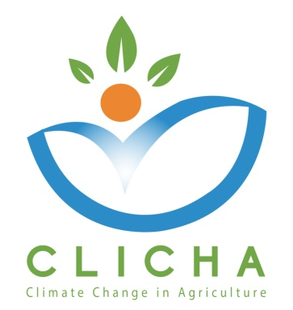

Event Evaluation-Info day:
"On-line teaching: what inputs and what current status in agricultural higher education institutions?"

WP 3 – Quality Assurance

AUA and CRETHIDEV
WP Leaders

February, 2019

CLICHA
CLIMATE CHANGE IN AGRICULTURE
Project Nr. 586273-EPP-1-2017-1-EL-EPPKA2-CBHE-JP
Document Data

Deliverable: Event evaluation - Info day: Improving the Teaching and Learning in the Tunisian High Education Sector
Work Package No & Title: WP3 - Quality Assurance
Work Package Leader: P1 - AUA (Greece)
Work Package Co-Leaders: P2 - CRETHIDEV (Greece)
Partners involved: P3 National Centre for Scientific Research “Demokritos” (DEMOKRITOS) - (Greece), P4 University of Jendouba (UJ) - (Tunisia), P5 - The University of Carthage (UCAR) - (Tunisia), P6 - University of Sousse (US) - (Tunisia), P7 - The National Institute of Field Crops (INGC) - (Tunisia), P8 - Centre of Adaptation to Climate Changes (CACC) - (Tunisia), P9 - Latvia University of Life Sciences and Technologies (LLU) - (Latvia), P10 – Università degli Studi di Torino (UNITO) - (Italy)
Distribution level: Partnership (Confidential)
Reviewed by: Consortium
Document Version: 0.1
Status: Draft

Document History

Version | Date | Author/Organization | Changes
0.1 | 28/02/2019 | Layla Ben Ayed, INAT | First Draft

Disclaimer

This project has been funded with the support of the Erasmus+ Programme of the European Union.

The information and views set out in this publication are those of the author(s) and do not necessarily reflect the official opinion of the European Commission and/or the Education, Audiovisual and Culture Executive Agency. Neither the European Commission nor the Education, Audiovisual and Culture Executive Agency, not any person acting on the Commission’s behalf and/or the Education, Audio-visual and Culture Executive Agency’s behalf, may be held responsible for any use which may be made of the information contained therein.

All rights are reserved. Reproduction is authorized, except for commercial purposes, provided the source is acknowledged.

Copyright © CLICHA Consortium, 2017-2020

Event evaluation

The purpose of this evaluation is to assess delivery and impact of the event regarding the capitalization of the project results and outputs as well as their dissemination to attract peers and widen the basis of project results’ recipients for better exploitation.

Participants

The event was organized by INAT and there were seven (7) participants: members from INAT organization and other partner organizations.

Results Presentation
The assessment is presented below, in %, (1 is Poor and 5 is Very Good) | 1  Poor | 2 | 3 | 4 | 5  Very Good
- What is your opinion of the general organization and facilities of the event? |  |  |  | 14 | 86
- To which extent did the event live up to your expectations? |  |  |  | 14,00 | 86,00
- What is your opinion of the presenters/facilitators? |  |  |  | 14,00 | 86,00
- How do you evaluate the information and the material that was distributed before and during the event? |  |  |  | 57,00 | 43,00
- How do you evaluate the agenda of the event? |  |  |  | 14,00 | 86,00
- How do you evaluate the technical resources used? |  |  |  | 86,00 | 14,00
- How effective do you think was the methodologies used? |  |  |  | 71,00 | 29,00
- How useful was the event? |  |  |  |  | 100,00
- How valuable was the event for your professional growth? |  |  |  | 28,00 | 72,00
- How satisfied are you from the level of participation to the event proceedings? |  | 14,00 |  | 28,00 | 57,00
- Do you feel that the targets of the event have been fulfilled? |  |  | 14,00 |  | 86,00
- How do you evaluate the accommodation and catering of the event? |  |  |  |  | 100,00

Conclusions and Recommendations
The assessment was very positive in all indices, since more than 85% of the participants gave scores between 4 and 5 on a 5-point Likert scale,where 1 is Poor and 5 is Very Good.

